

**College of Science, Technology & Applied Arts of Trinidad & Tobago**

**DEPARTMENT OF INFORMATION SCIENCE AND TECHNOLOGY**

**FINAL PROJECT COVER PAGE**

**ASSIGNMENT TITLE: FINAL PROJECT**

**COURSE CODE: ITEC 240**

**COURSE TITLE: DATABASE ADMINASTRTION 2**

**CRN: 22005 SEMESTER: 2**

**STUDENT: TEELON MITCHELL 00048797**

**LYNODN MAYNARD 00048678**

**IT: COMPUTER INFORMATION SYSTEMS**

**DATE OF SUBMISSION: 11/05/2017**

**LECTURER’S NAME: NICLOE A, BENNETT ALEXANDER**

Contents

Site Purpose 3

Audience 3

Stats 3

Storyboard 4

Basic Layout Design 4

Home Page Design 5

Products page Design 5

About Us Page Design 6

Contact Us Page Design 6

Thank You Page Design 7

Screen Shots 8

Home Page 8

Products Page 8

Contact Page 9

Thank You Page 10

About Us Page 10

# Site Purpose

The purpose of this site is a cart dealer ship web site that shows customers the vehicles available for purchase from the company. The company contacted us to give the company an online present to the country, give customer a vivid idea of the types of vehicles provided by the them and increase communication between the company and potential customers. So, to complete this task we created a light clean, and colorful site to make it easy and enjoyable for customers to research and contact the company.

# Audience

* Working Males and females
* Companies looking to buy their own vehicles

## Stats

* 4 out of 5 use smartphones to shop for cars
* 1 in 3 shoppers used multiple devices to research prior to visiting a dealership.
* 9% of households is looking for a car.

# Storyboard

## Basic Layout Design

The site has a simple design with a two-column design. The left column of the site holds the navigation and logo of the entire site. The page the user is on will be represented by highlighting the menu option on the left column. The right column of the site will contain all the information pertaining to the option chosen in the menu. The left column of the main table is fixed in order for the menu to stay in one place. The right column is also fixed but the height is not so that the page can scale as information is added.

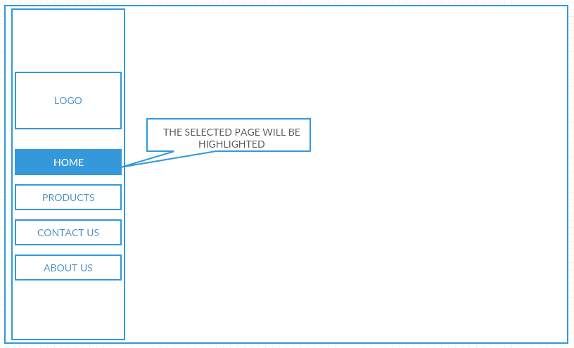

## Home Page Design

The home page has a simple design with the logo to the top of the right column, an introduction to the company of the site to the below and a picture underneath the introduction.

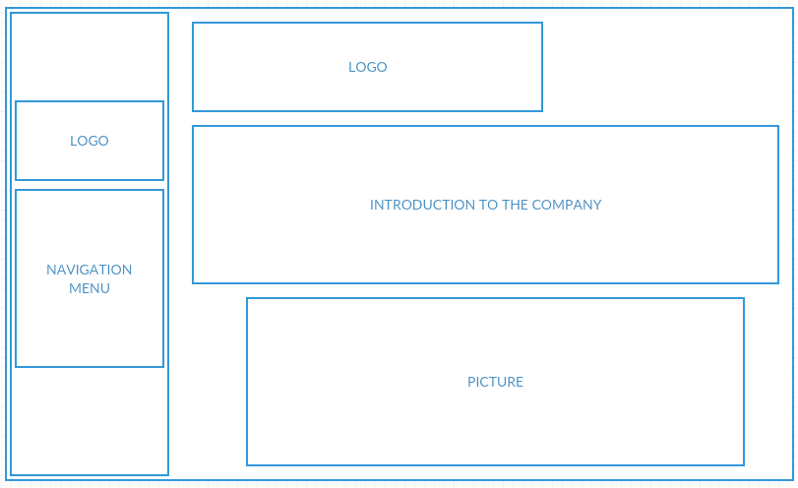

## Products page Design

The production page is a gallery of picture for the company. A number of tables was used to achieve a gallery with three different rows and each row having different number of columns

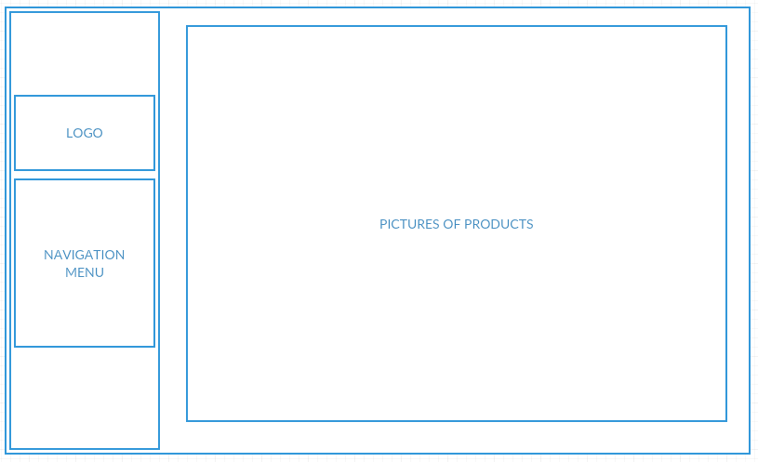

## About Us Page Design

The about page shows the workers of the company after the logo, a two column table is used to position the employees on this page, after the employees a descriptive paragraph about the company .

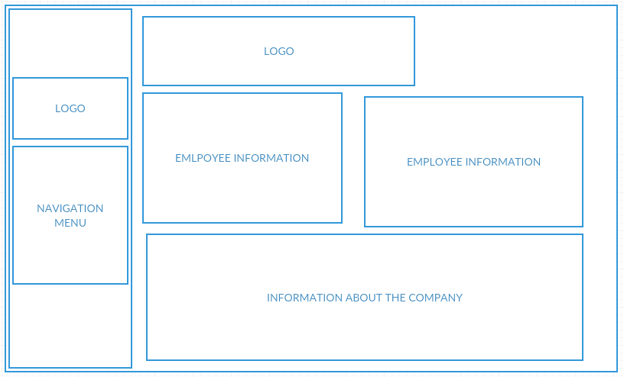

## Contact Us Page Design

The contact page has the company logo to the top as while. After the logo, all of the offices with their contact information like email address and phone number is placed on the page. The contact form is then placed in case a user has any question for the company.

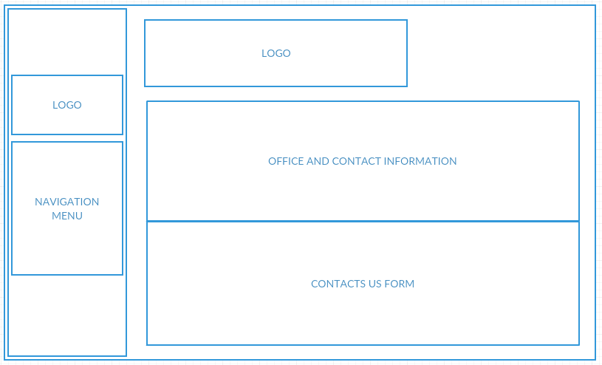

## Thank You Page Design

The logo is once again on the top of this page. The purpose of this page is to inform the user that their information entered in contact us page was received by us we will contact them soon concerning it.

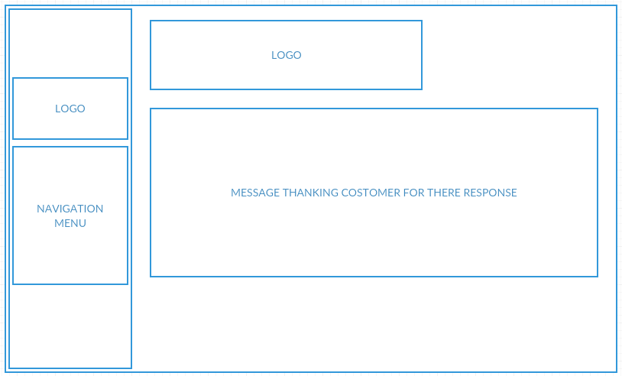

# Screen Shots

## Home Page

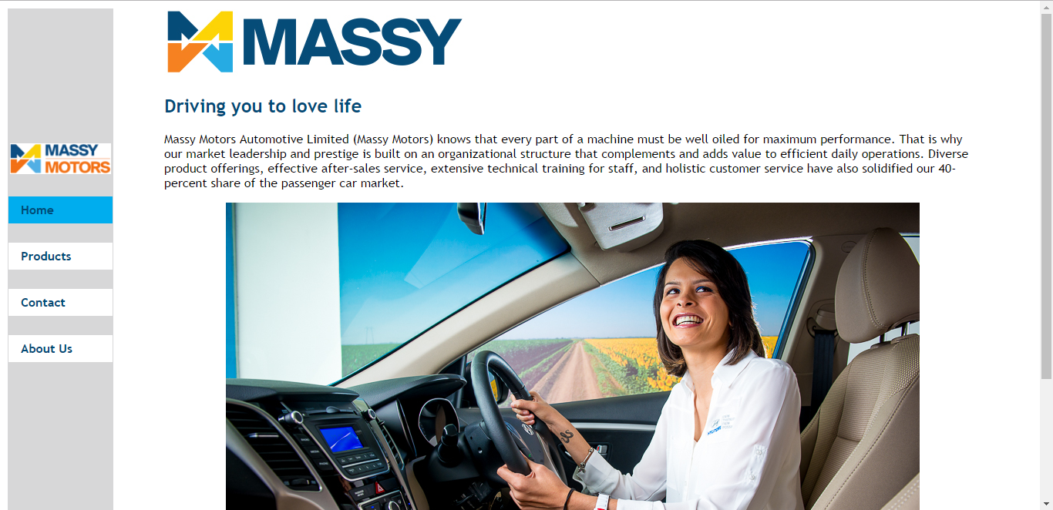

Products Page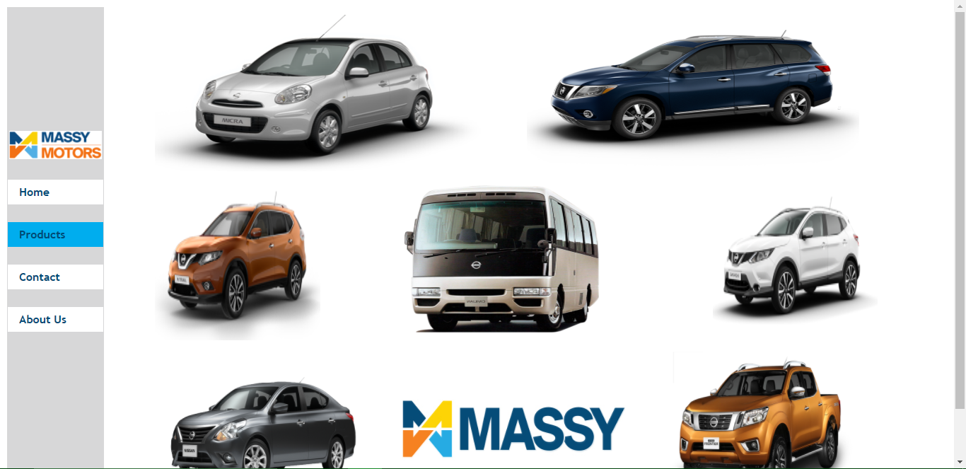

Contact Page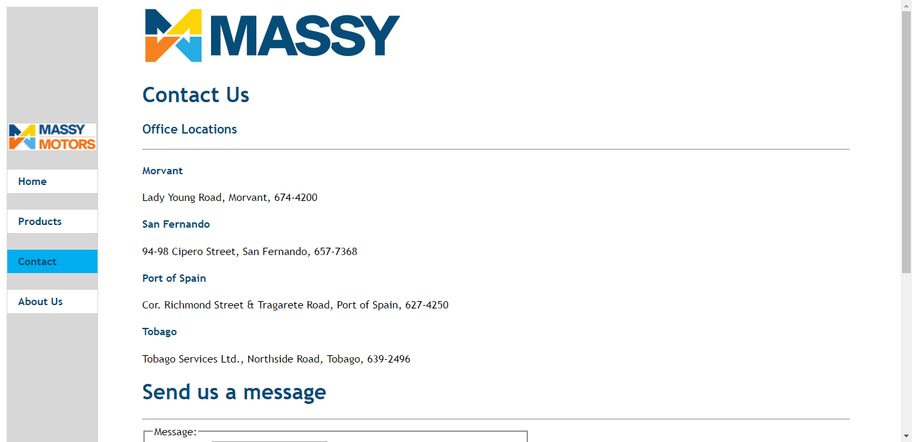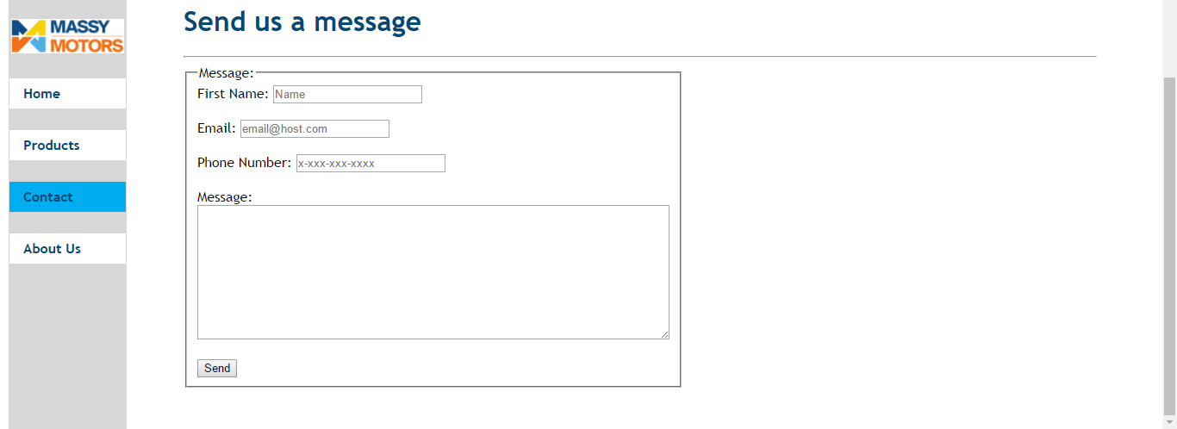

## Thank You Page

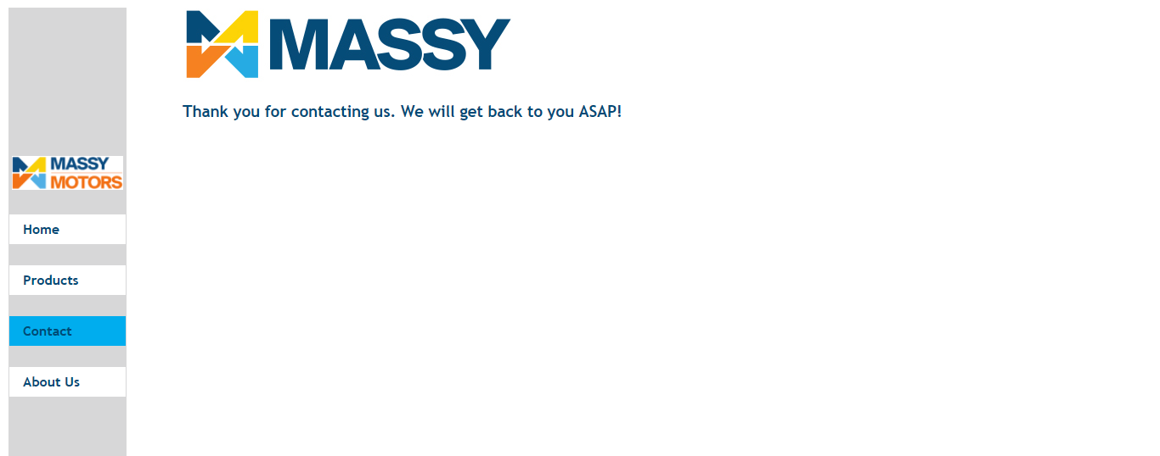

About Us Page